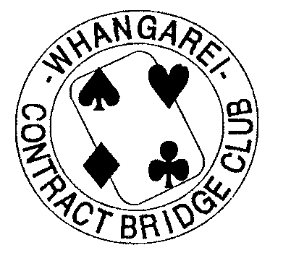

nc.)

NORTHLAND/AUCKLAND
REGIONAL TEAMS

10A TOURNAMENT

Sunday 18th July 2021

CLUB ROOMS, 17 NORTH STREET, WHANGAREI

• Morning tea 9.00 am
• Start 9.30 am
• Bring Your Own Lunch

ENTRY FEE $160.00 per team

ENTRIES, CONTACT NOS, & COMPUTER NOS TO

Tournament Secretary
Lee Walters
Phone: (021) 1323287 text messages accepted

email:whgtournament@gmail.com

CLOSING DATE Wednesday 14th July 2021

